**DBMS LAB TASK-2**

**Name: Kommaraju Jahnavi**

**Reg No. : 121910306007**

**Section: B6**

1. **CREATE A RELATIONS FOR THE BELOW ER MODEL**

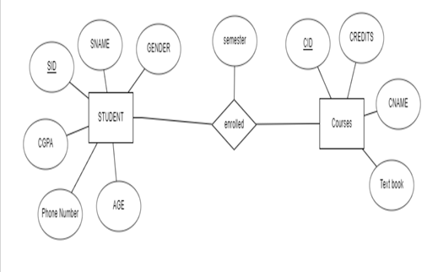

For Student Table:

CREATE TABLE STUDENT(SID INTEGER PRIMARY KEY, SNAME VARCHAR(10), GENDER VARCHAR(10), CGPA REAL, PHNO INTEGER, AGE INTEGER);

**Output:**

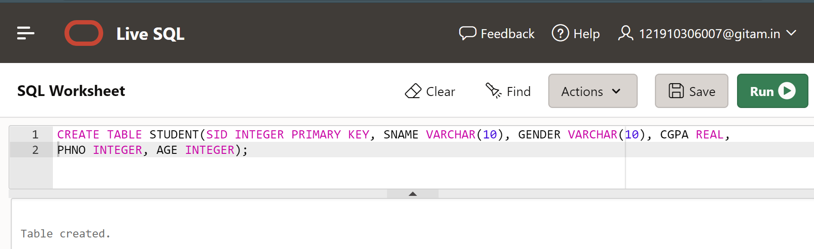

For Course Table:

CREATE TABLE COURSE(CID INTEGER PRIMARY KEY, CNAME VARCHAR(10), CREDITS INTEGER,TEXTBOOK VARCHAR(20));

**Output:**

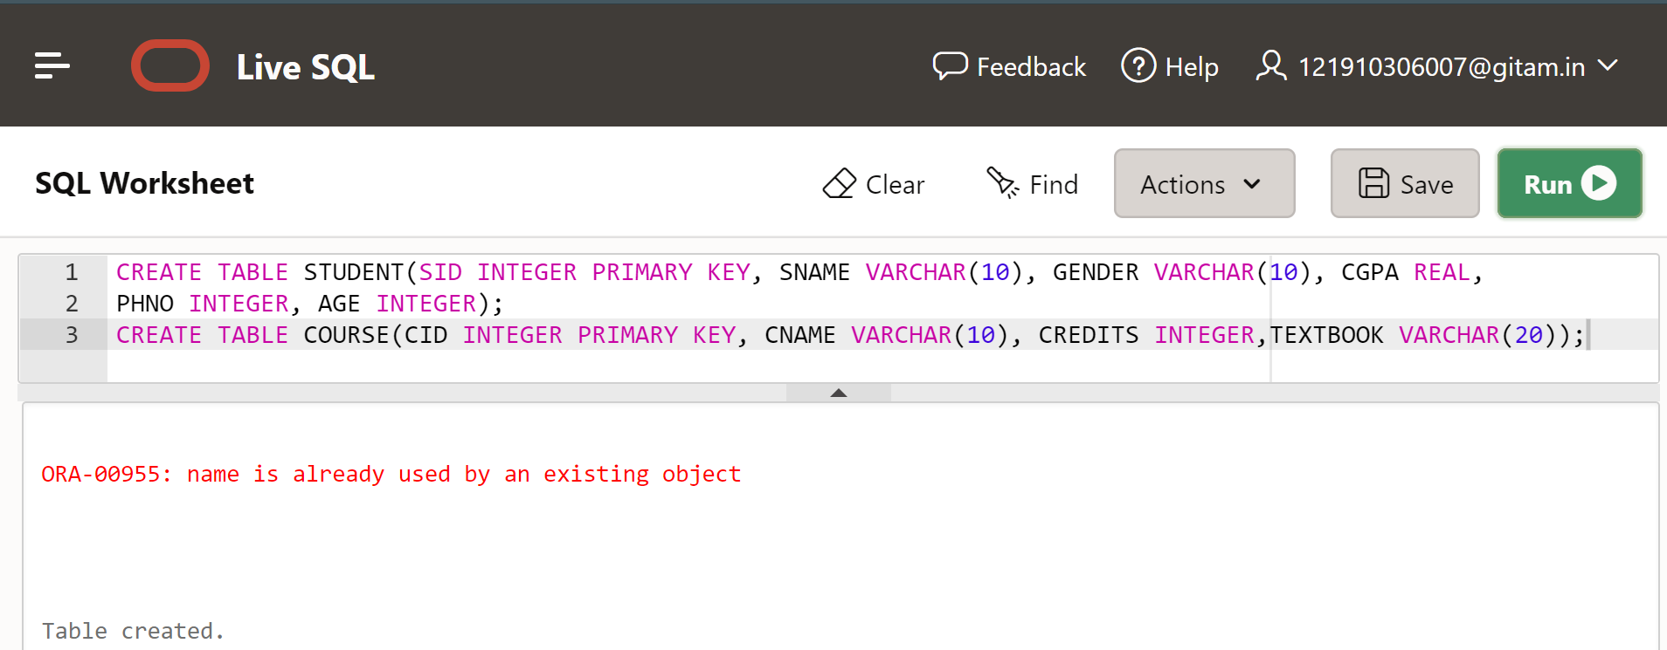

For Enrolled Table:

CREATE TABLE ENROLLED(SID INTEGER, CID INTEGER, SEMESTER VARCHAR(10), PRIMARY KEY(SID,CID), FOREIGN KEY(SID) REFERENCES STUDENT, FOREIGN KEY(CID) REFERENCES COURSE);

**Output:**

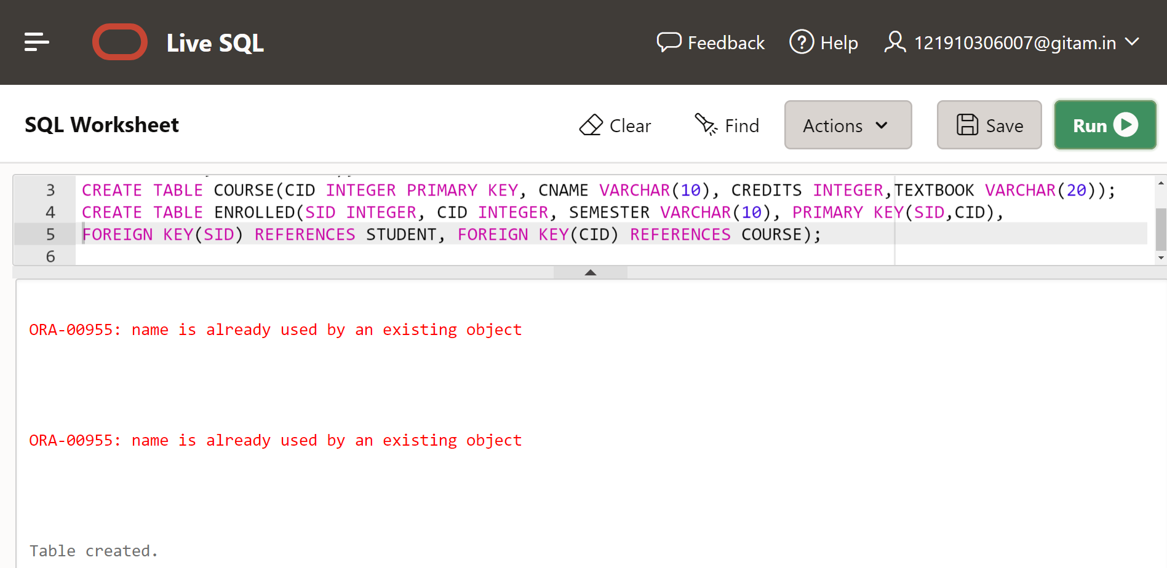

1. **INSERT The values in a Relations of above ER Model.**

**Student**

| **SID** | **SNAME** | **GENDER** | **CGPA** | **PHONE NUMBER** | **AGE** |
| --- | --- | --- | --- | --- | --- |
| **55** | **Kavya** | **FEMALE** | **9.0** | **95565** | **20** |
| **56** | **Karthika** | **FEMALE** | **9.5** | **55566** | **20** |
| **57** | **Manasa** | **FEMALE** | **8.5** | **22655** | **21** |
| **58** | **Bharthi** | **FEMALE** | **9.2** | **25555** | **22** |

INSERT INTO STUDENT(SID, SNAME, GENDER,CGPA,PHNO,AGE) VALUES(55,'Kavya','Female',9.0,95565,20);

INSERT INTO STUDENT(SID, SNAME, GENDER,CGPA,PHNO,AGE) VALUES(56,'Karthika','Female',9.5,55566,21);

INSERT INTO STUDENT(SID, SNAME, GENDER,CGPA,PHNO,AGE) VALUES(57,'Mansa','Female',8.5,22655,21);

INSERT INTO STUDENT(SID, SNAME, GENDER,CGPA,PHNO,AGE) VALUES(58,'Bharthi','Female',9.2,25555,22);

**Output:**

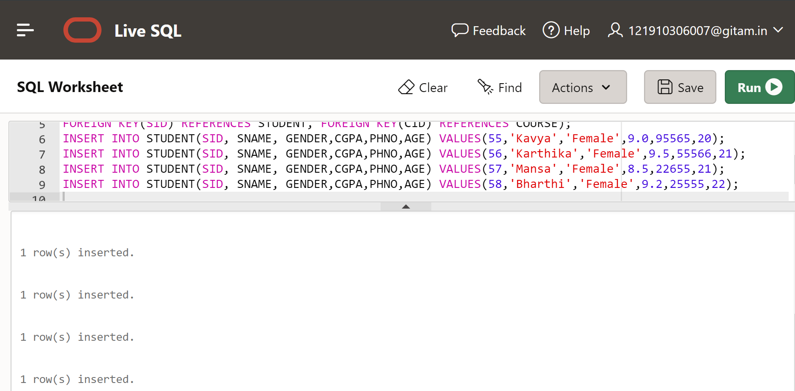

**Display Student table details:**

SELECT *FROM STUDENT;

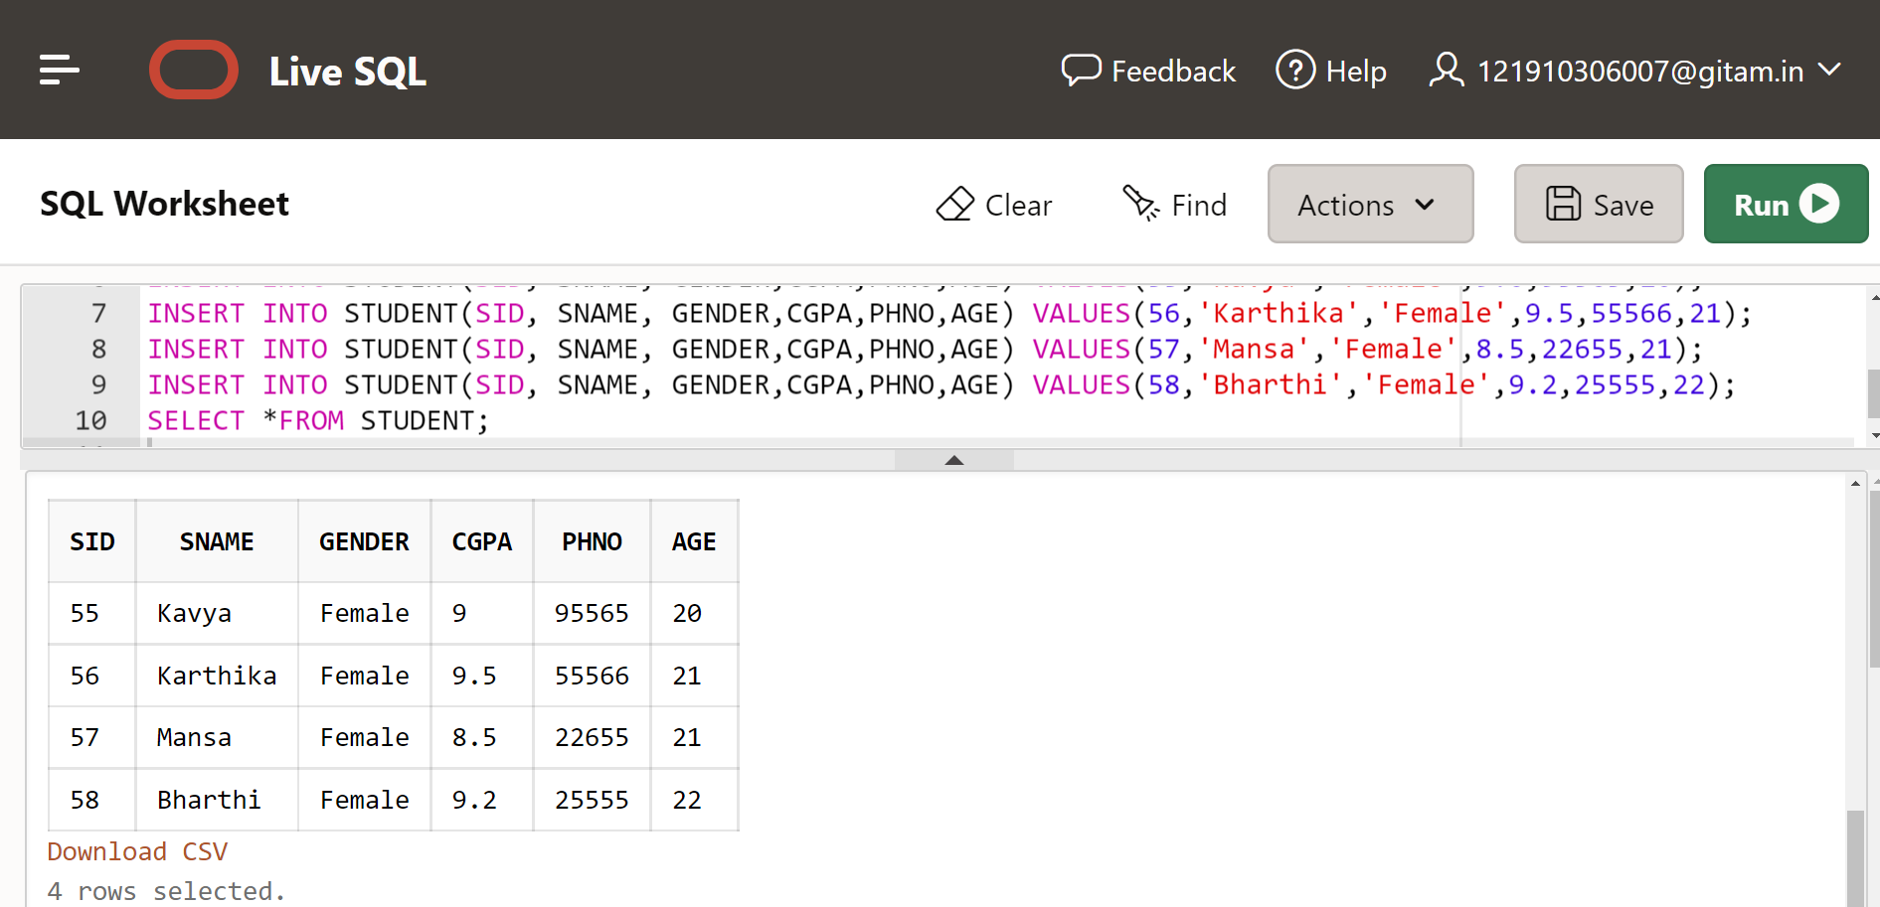

**Course**

| **CID** | **CNAME** | **CREDITS** | **Text Book** |
| --- | --- | --- | --- |
| **101** | **DBMS** | **4** | **Raghu Ramakrishna** |
| **102** | **FLAT** | **3** | **Puntambekar** |
| **103** | **OOPS** | **3** | **Grady Booch** |

INSERT INTO COURSE(CID,CNAME,CREDITS,TEXTBOOK) VALUES(101,'DBMS',4,'Raghu Ramakrishna');

INSERT INTO COURSE(CID,CNAME,CREDITS,TEXTBOOK) VALUES(102,'FLAT',3,'Puntambekar');

INSERT INTO COURSE(CID,CNAME,CREDITS,TEXTBOOK) VALUES(103,'OOPS',3,'Grady Booch ');

**Output:**

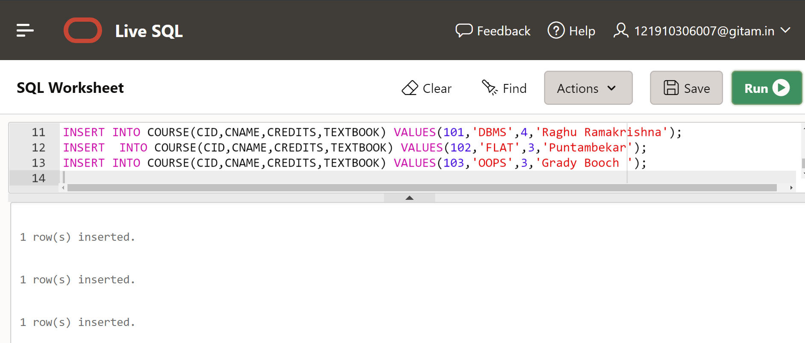

**Display Course table details:**

SELECT * FROM COURSE;

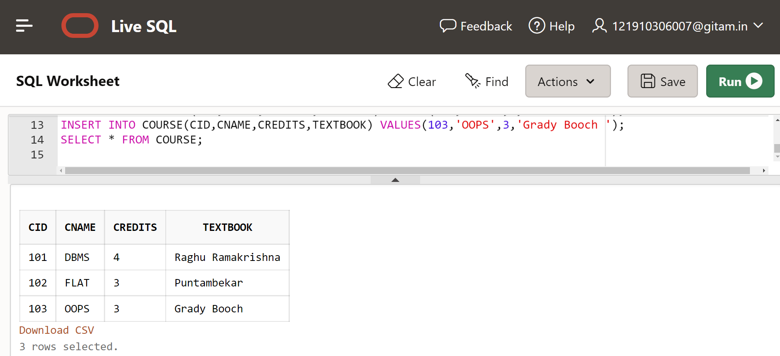

**Enrolled**

| **SID** | **CID** | **Semester** |
| --- | --- | --- |
| **56** | **101** | **ODD** |
| **58** | **103** | **EVEN** |
| **55** | **102** | **ODD** |

INSERT INTO ENROLLED(SID,CID,SEMESTER) VALUES(56,101,'ODD');

INSERT INTO ENROLLED(SID,CID,SEMESTER) VALUES(58,103,'EVEN');

INSERT INTO ENROLLED(SID, CID, SEMESTER) VALUES(55,102,'ODD');

**Output:**

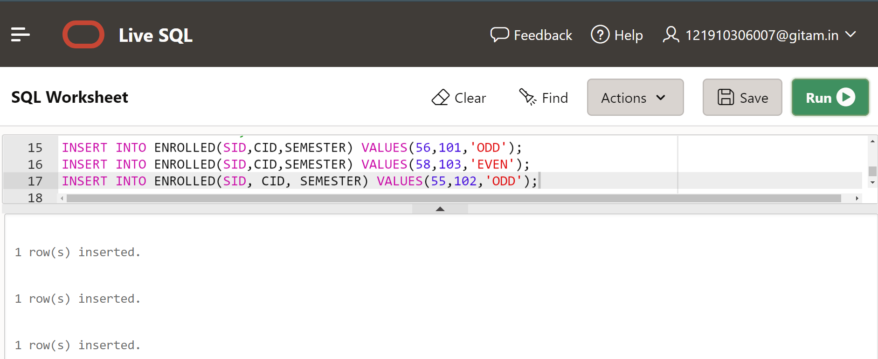

**Display ENROLLED table details:**

SELECT * FROM ENROLLED;

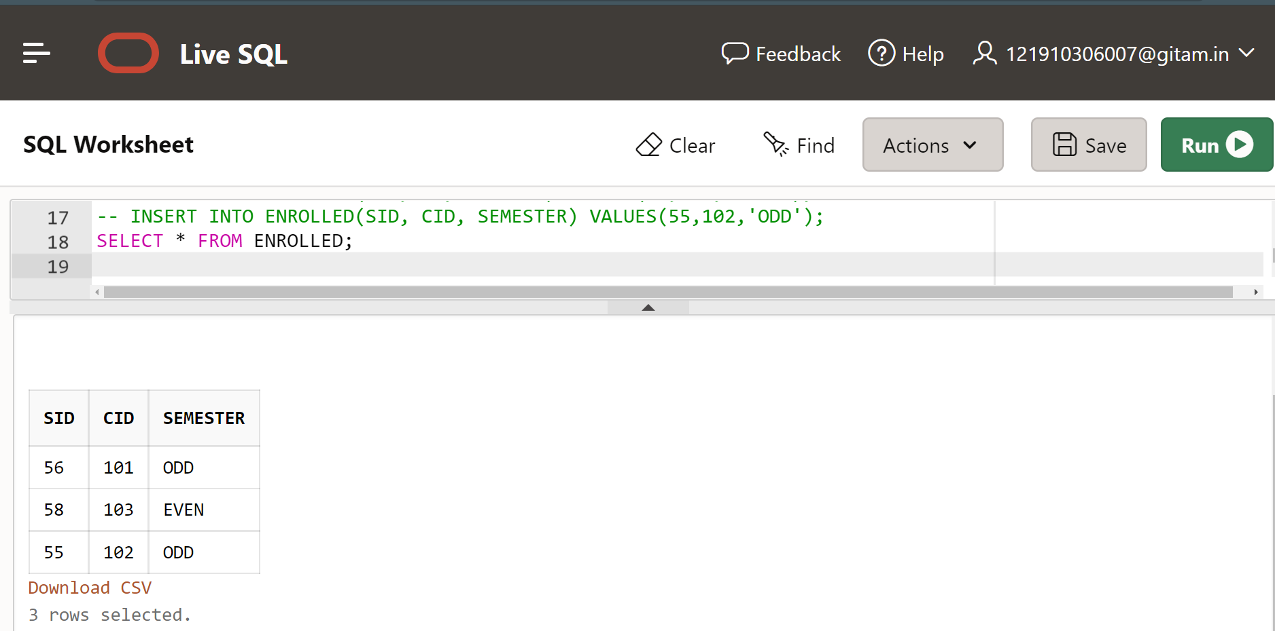

1. **See the description of the table – column name and data type of the table created.**

For Student Table:

**DESC STUDENT;**

**Output:**

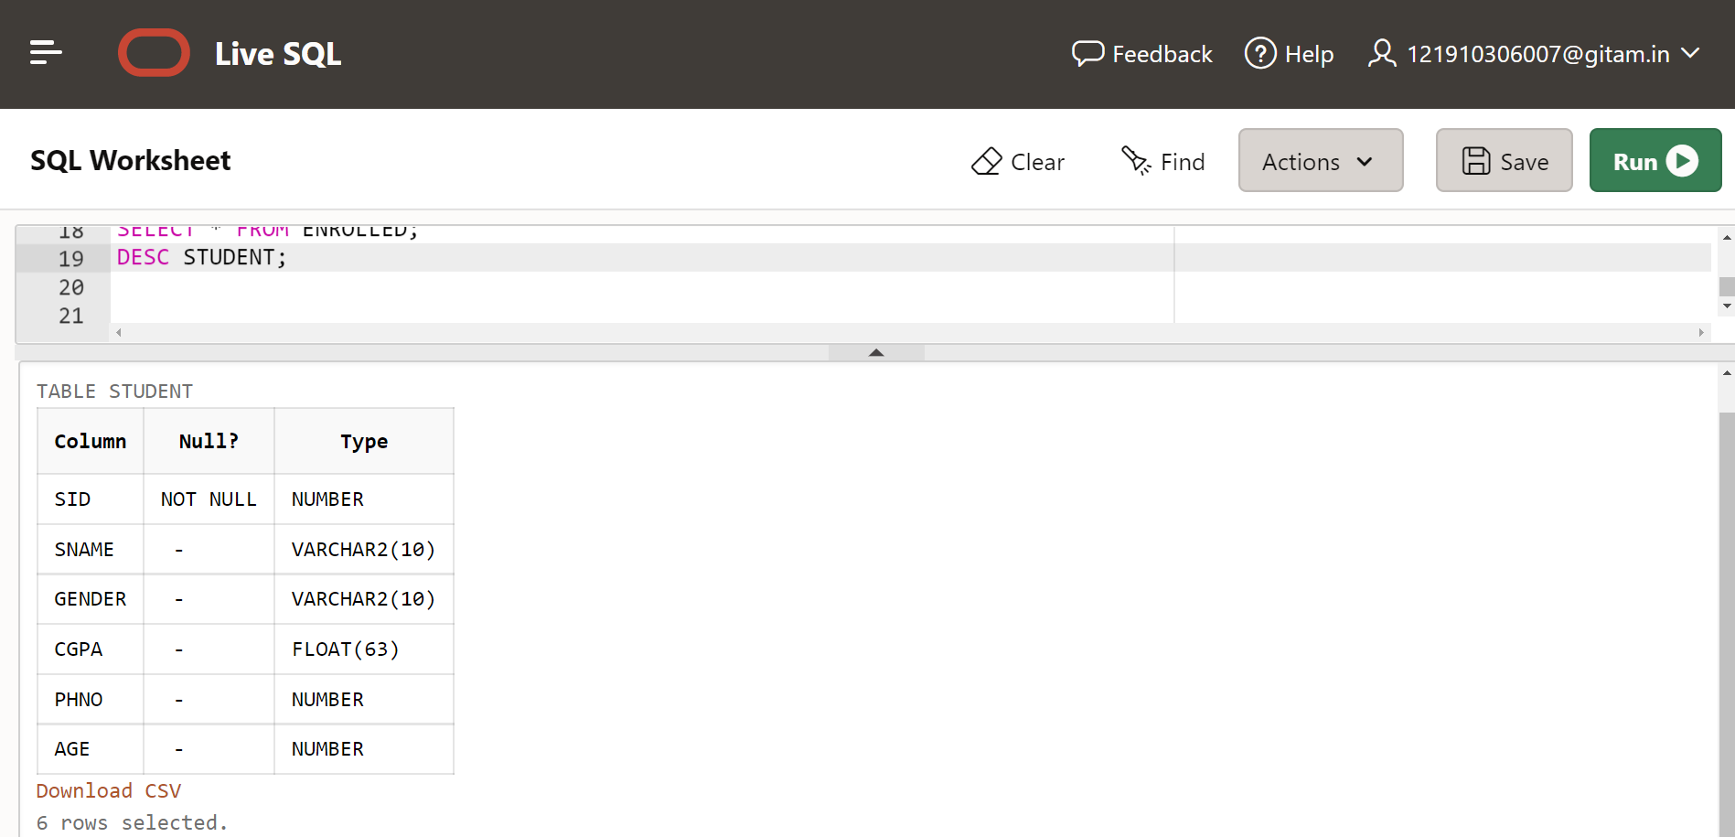

For COURSE Table:

**DESC COURSE;**

**Output:**

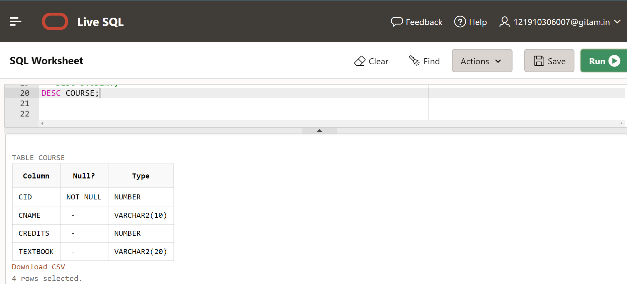

For ENROLLED Table:

**DESC ENROLLED;**

**Output:**

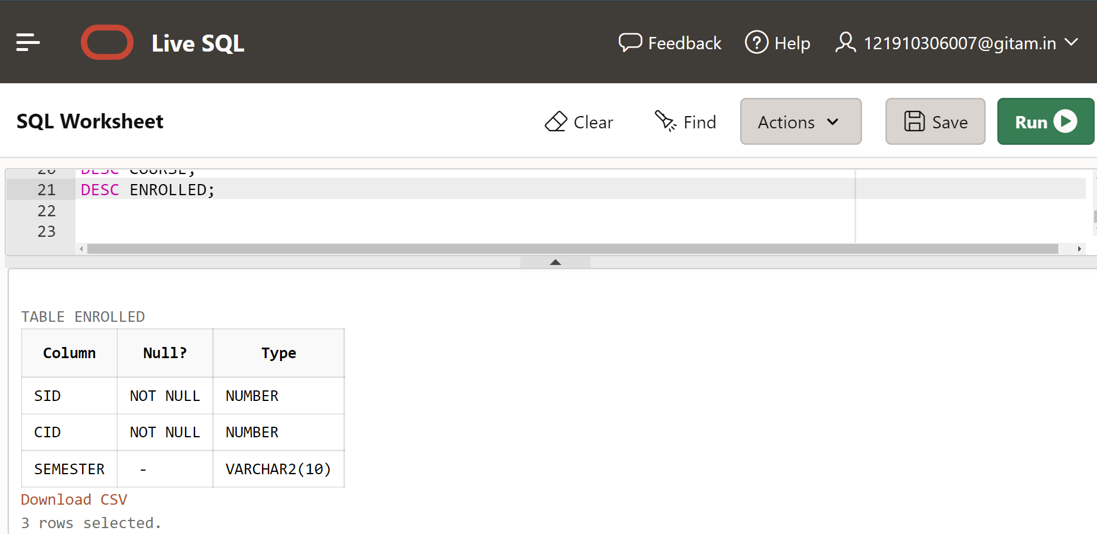

1. **Insert the given values (60,102, EVEN) in Enrolled Relation and Identify the Result.**

INSERT INTO ENROLLED(SID, CID, SEMESTER) VALUES(60,102,'ODD');

Output:

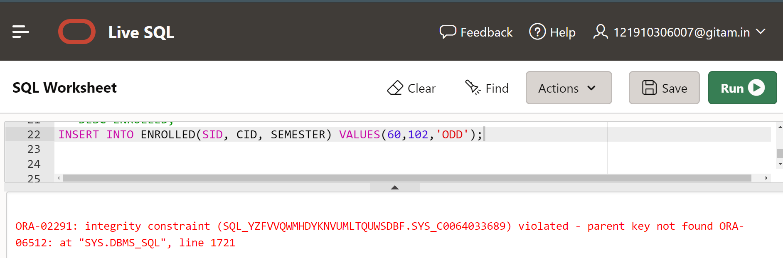

Solution for the above error:

To insert the values into Enrolled Relation, we first need to insert the SID value into the Student table and Course table already have a CID value 102 and then insert values into Enrolled table

COMMANDS:

INSERT INTO STUDENT(SID) VALUES(60);

INSERT INTO ENROLLED(SID,CID,SEMESTER) VALUES(60,102,'EVEN');

SELECT * FROM ENROLLED;

**Output:**

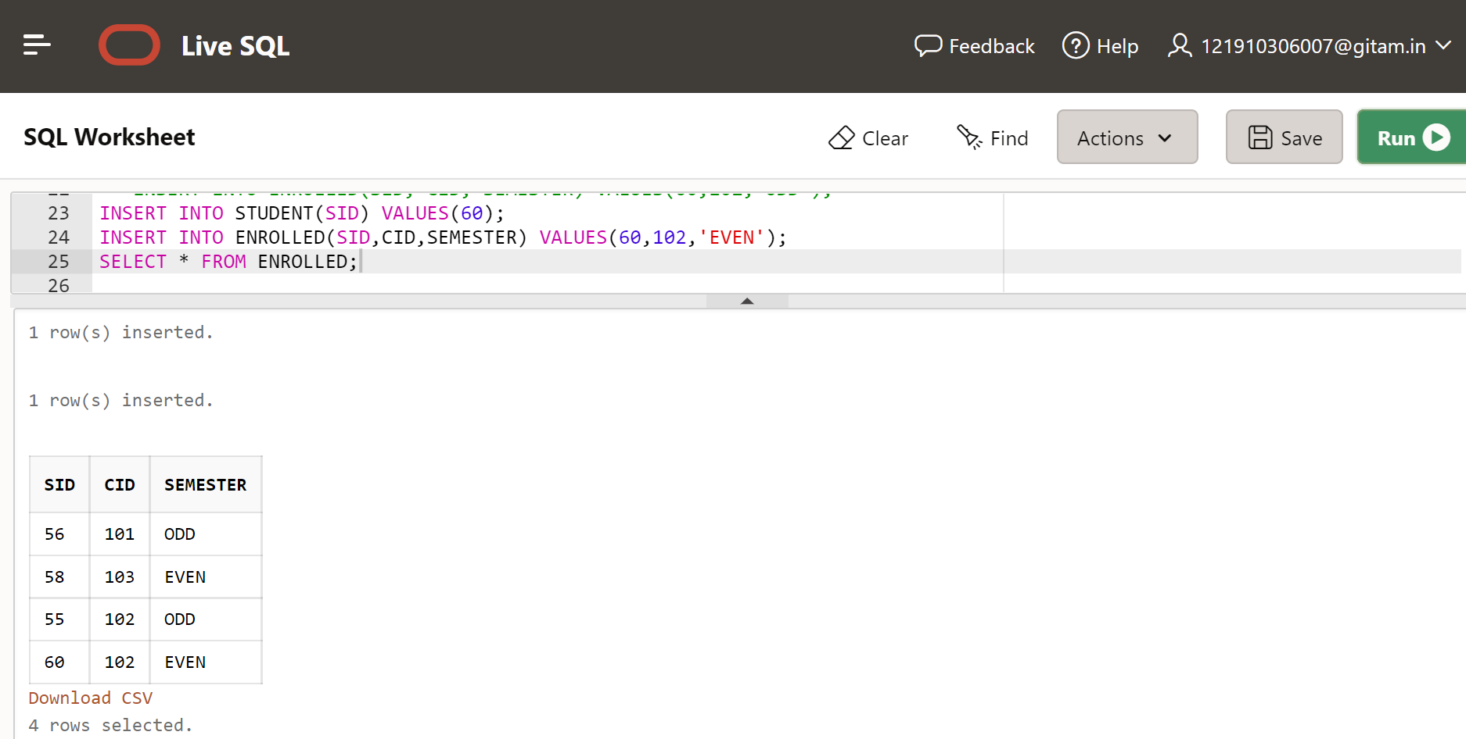

1. **Update the Sname as Sravani at SID = 55. Write the Result.**

UPDATE STUDENT

SET SNAME='SRAVANI'

WHERE SID=55;

SELECT * FROM STUDENT;

**Output:**

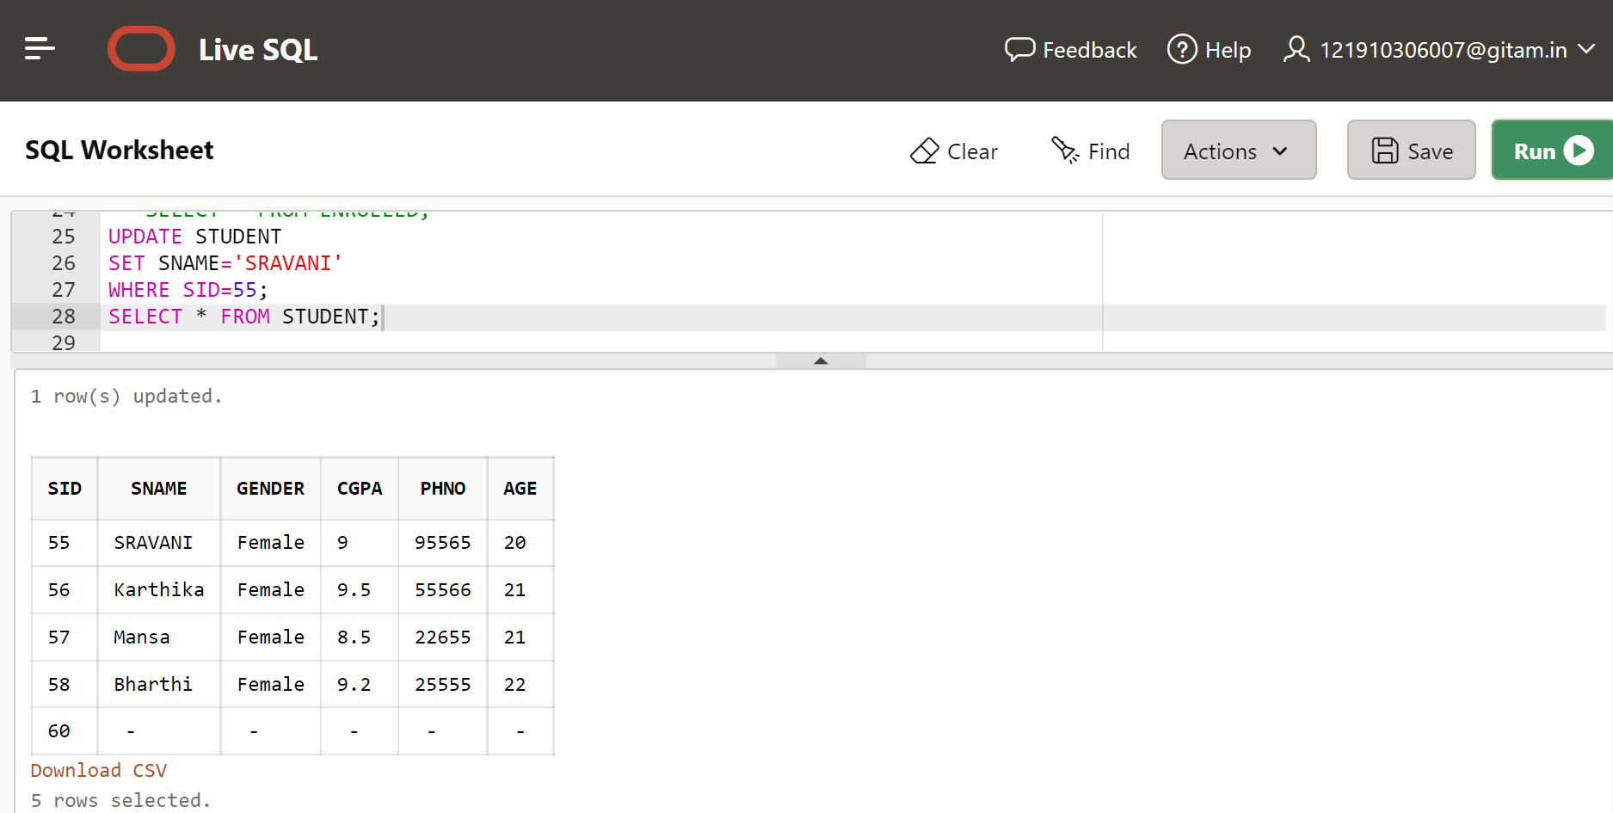

1. **RENAME the Course Table Name to Subjects. Display the Result.**

RENAME COURSE TO SUBJECTS;

SELECT * FROM SUBJECTS;

**Output:**

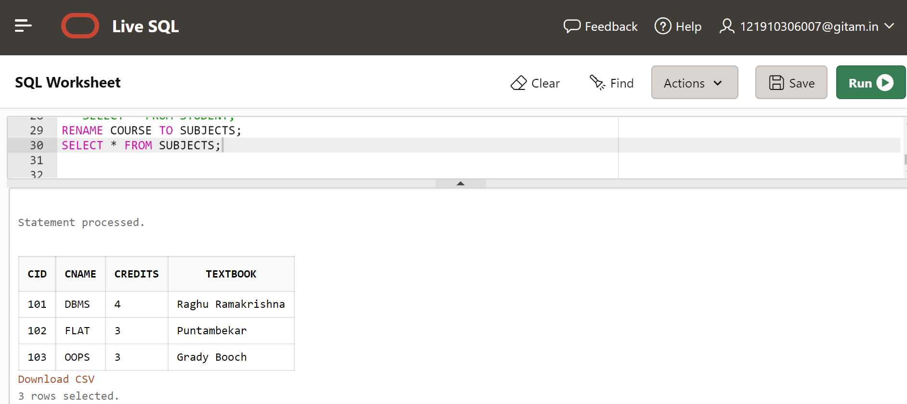

1. **ADD THE NEW Column as Reference Text Book in Course Relation. And Display the Result.**

ALTER TABLE SUBJECTS ADD REFERENCE_TB VARCHAR(20);

SELECT * FROM SUBJECTS;

**Output:**

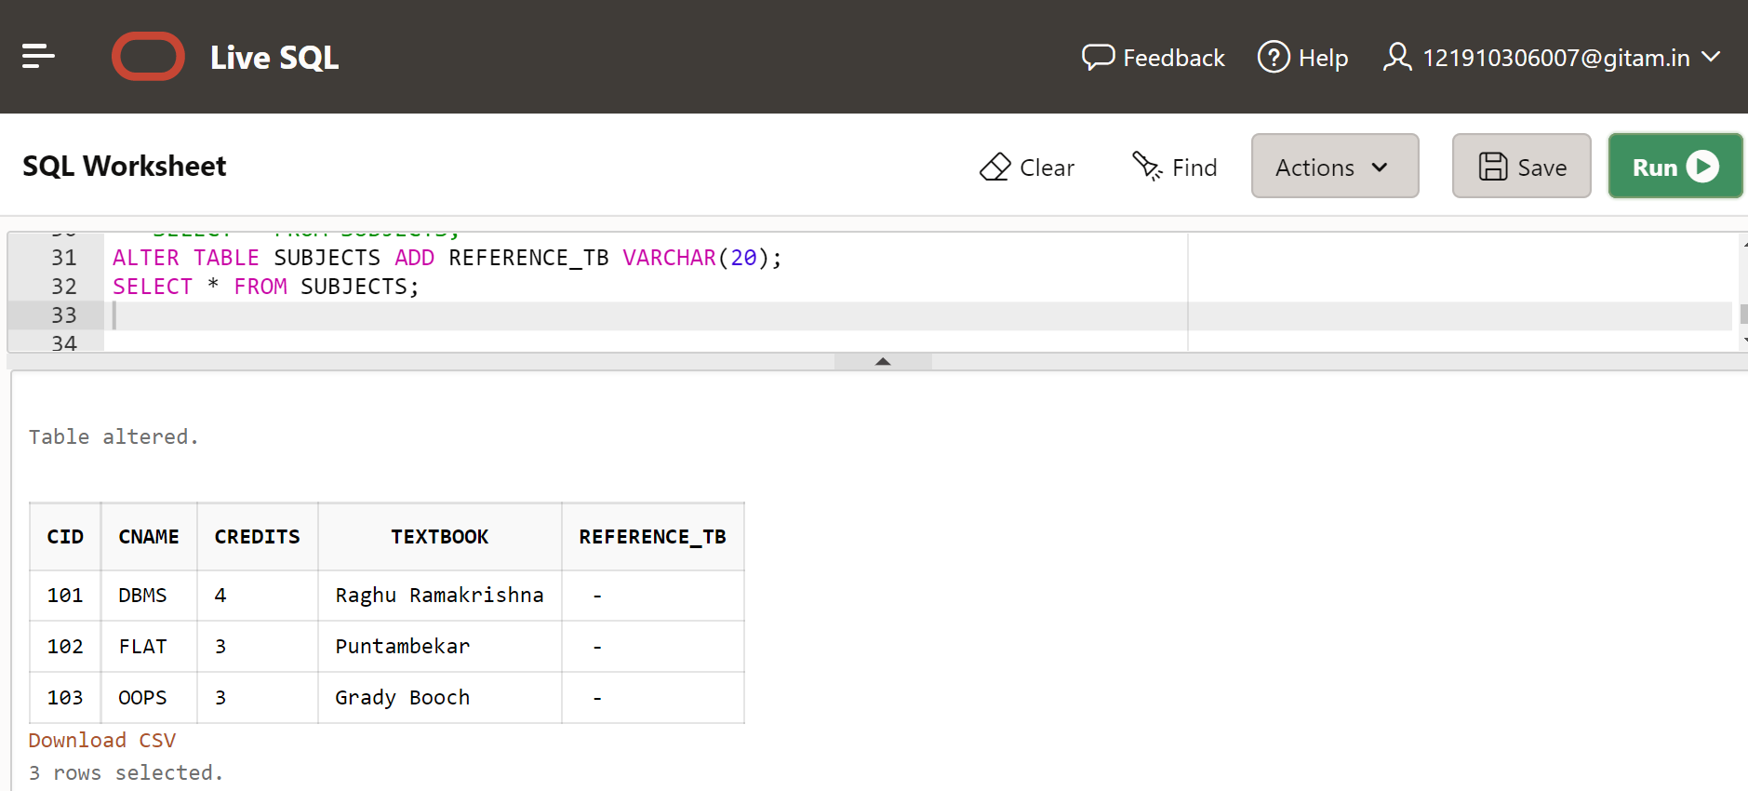

1. **Display the 3 Relations of the above ER Model.**

SELECT *FROM STUDENT;

SELECT * FROM SUBJECTS;

SELECT * FROM ENROLLED;

**Output:**

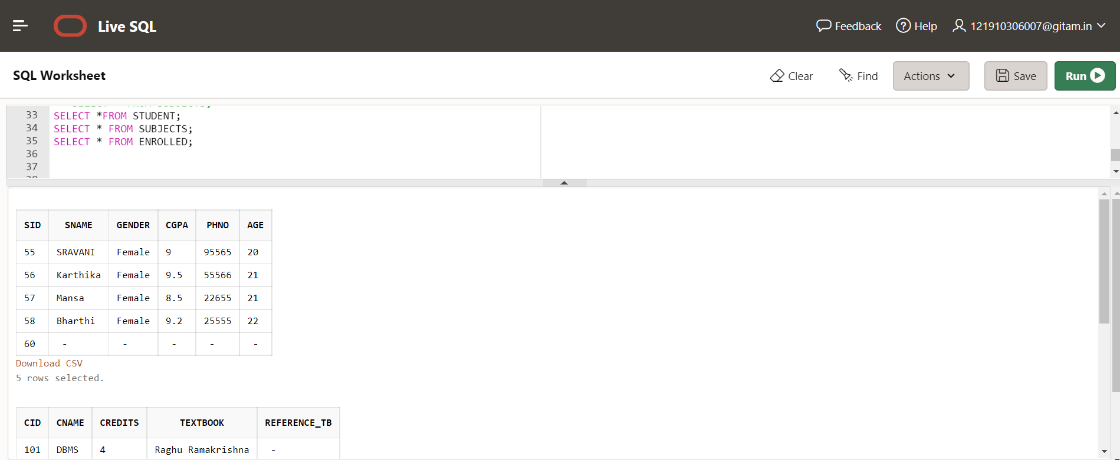

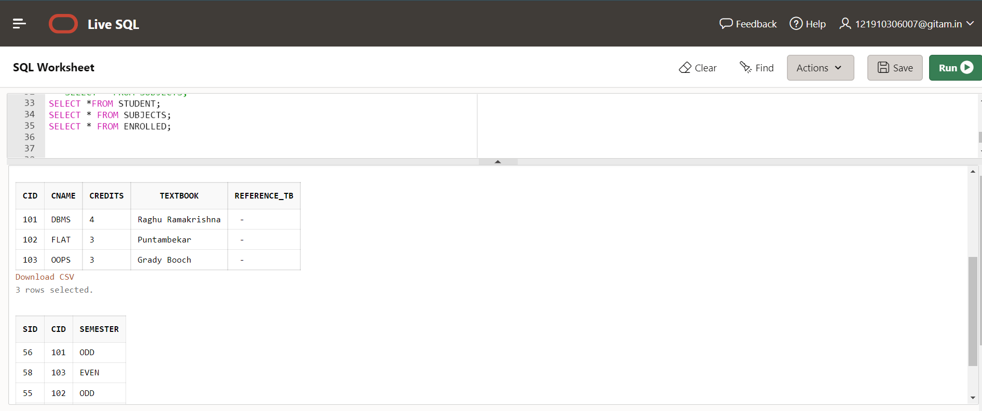

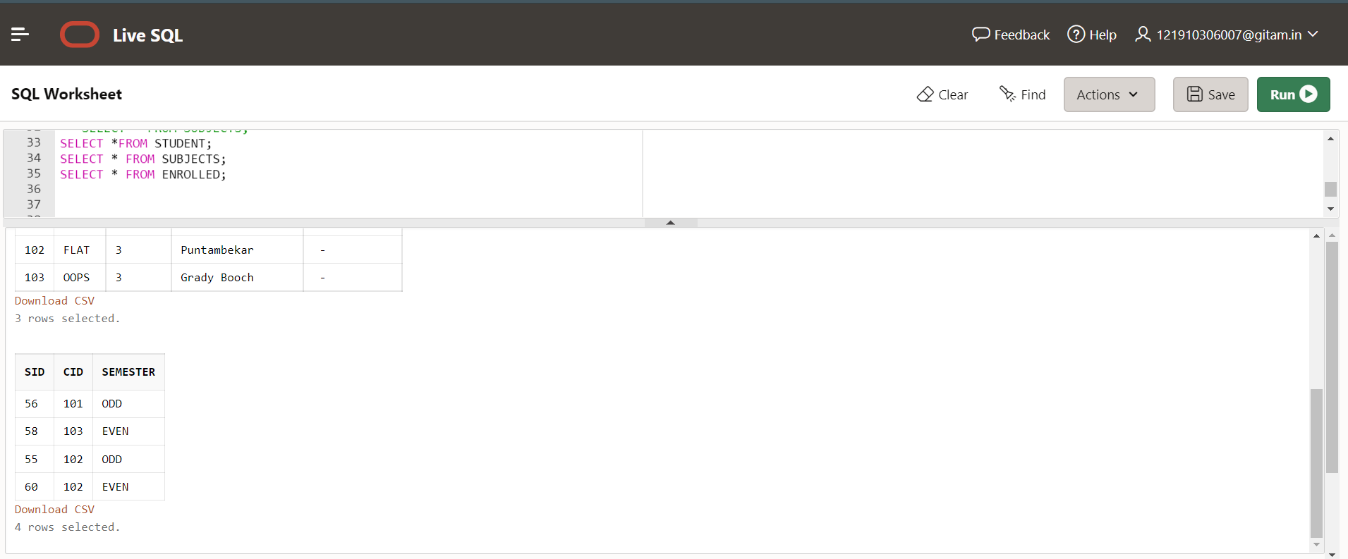

1. **Display the Cname and Textbook details whose Credits = 4**

SELECT CNAME,TEXTBOOK FROM SUBJECTS WHERE CREDITS=4;

**Output:**

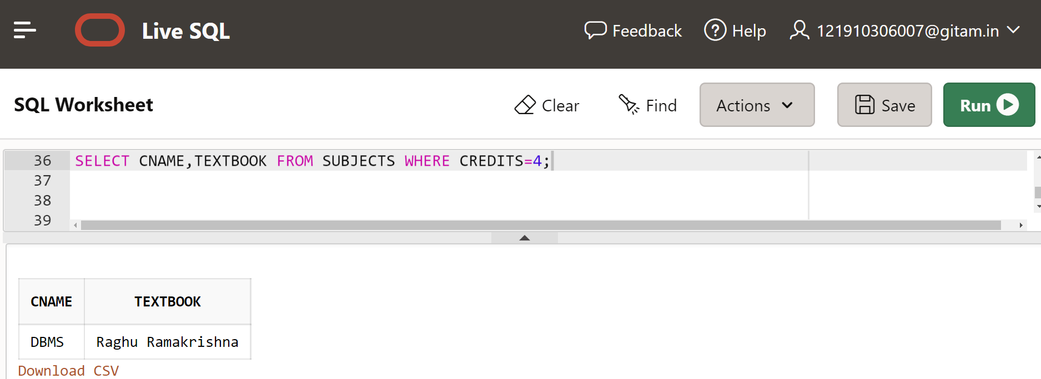

**10) Find the Names and SID who have enrolled in DBMS Course**

SELECT S.SID, S.SNAME

FROM STUDENT S, SUBJECTS C, ENROLLED E

WHERE S.SID=E.SID AND C.CID= E.CID AND C.CNAME='DBMS';

**Output:**

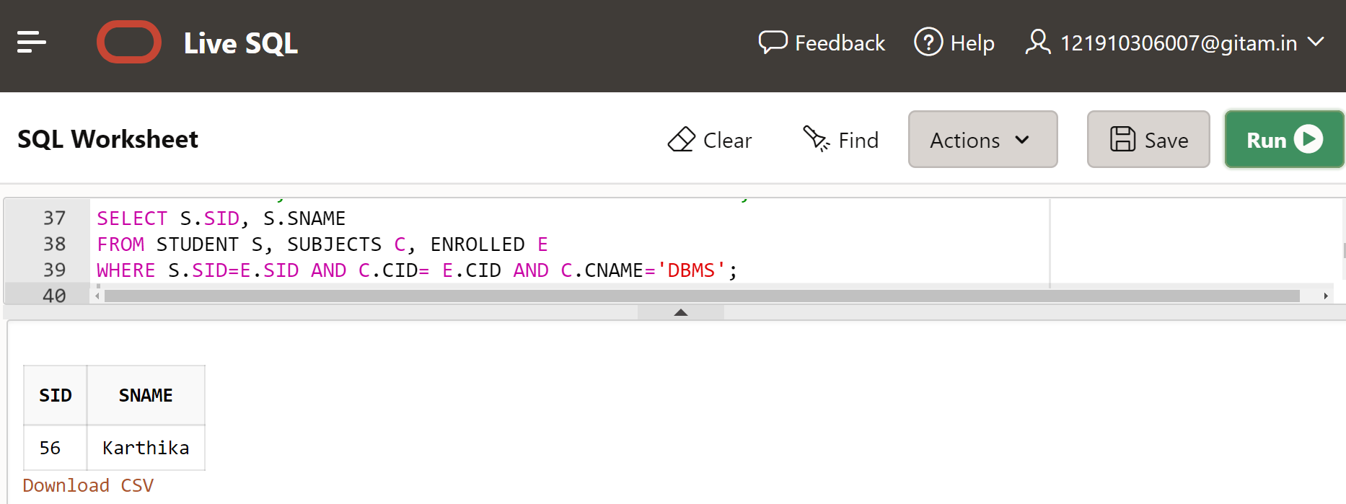

**11) Display the Sname and gender whose age is 25.**

SELECT SNAME,GENDER

FROM STUDENT

WHERE AGE=25;

Output:

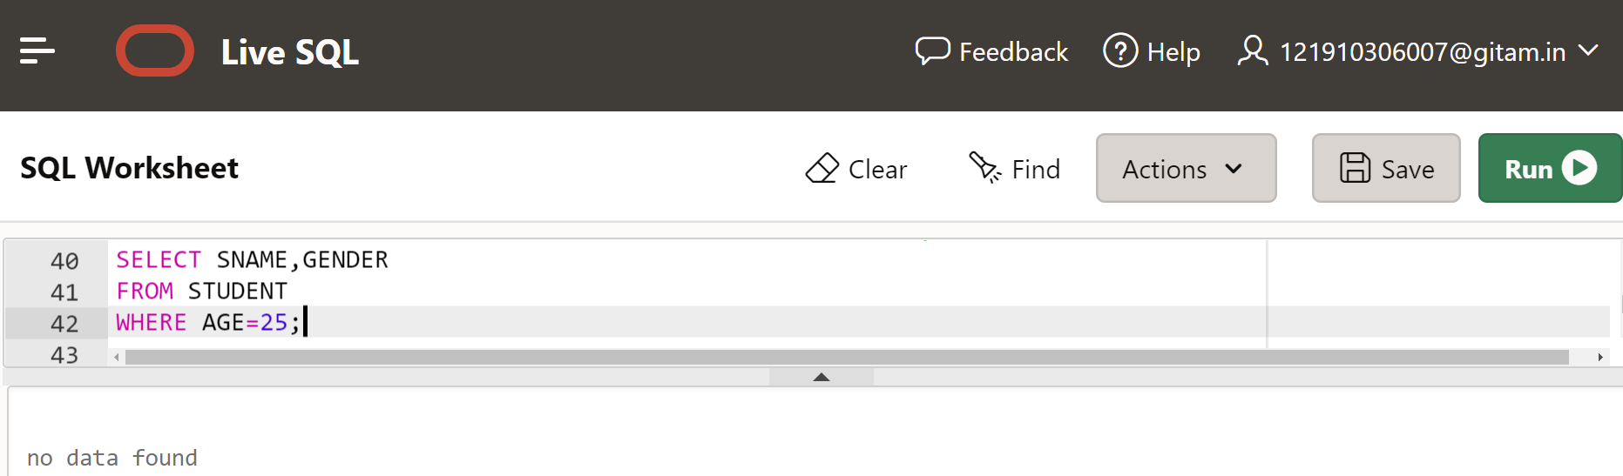

**Now,** before displaying values we need to update STUDENT table with the required values

For example,

UPDATE STUDENT

SET AGE=25,SNAME='JAHNAVI', GENDER='FEMALE'

WHERE SID=60;

SELECT * FROM STUDENT;

**Then, output:**

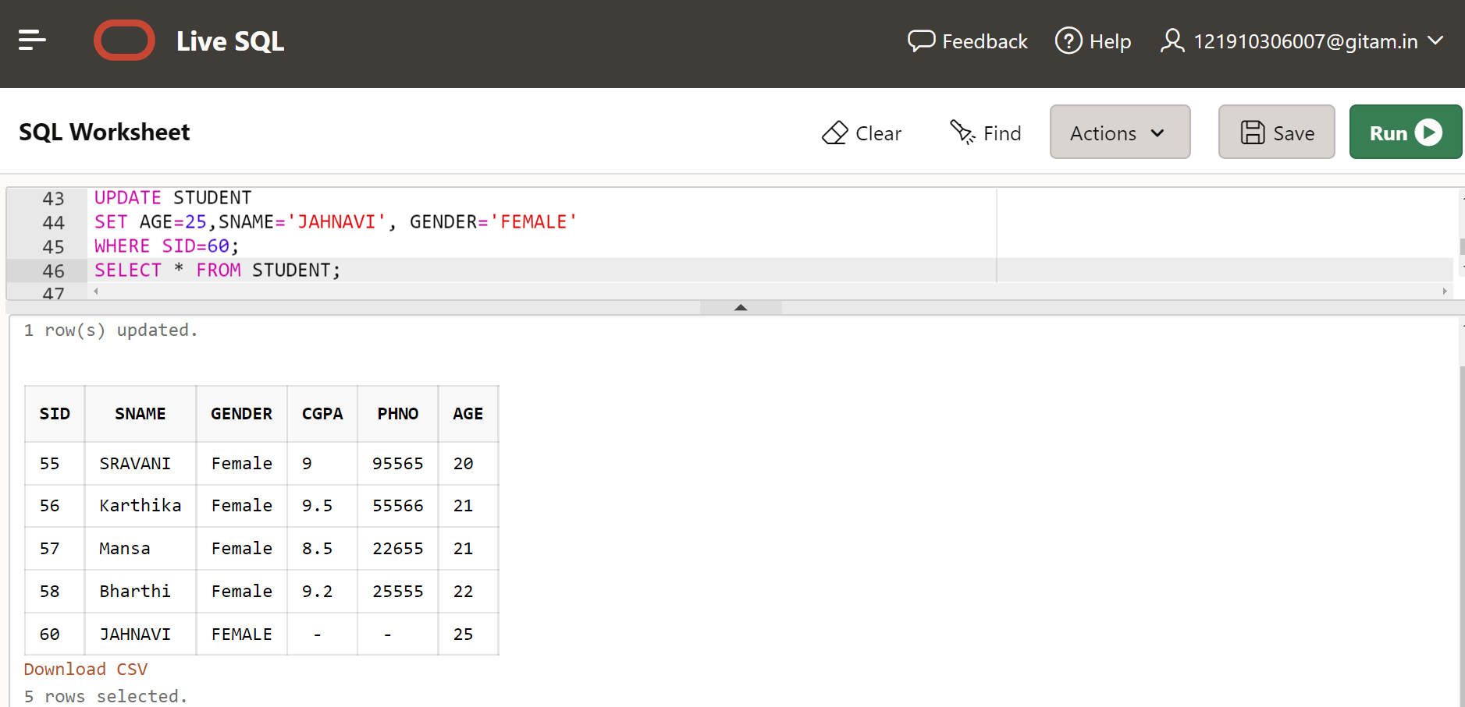

**Now,**

SELECT SNAME,GENDER FROM STUDENT WHERE AGE=25;

**Output:**

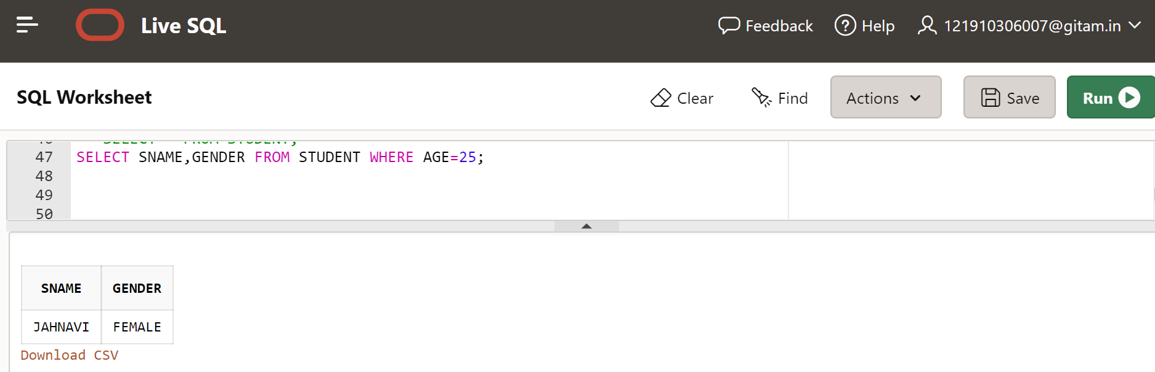

**12) Try to Modify the Data type of CNAME Column.**

ALTER TABLE SUBJECTS MODIFY CNAME CHAR(20);

DESC SUBJECTS;

**Output:**

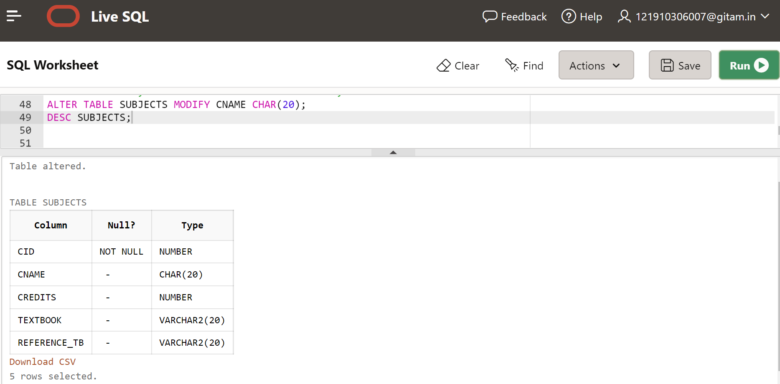

**13) Delete the Phone number whose sid is 57.**

UPDATE STUDENT SET PHNO=NULL WHERE SID=57;

SELECT *FROM STUDENT;

**Output:**

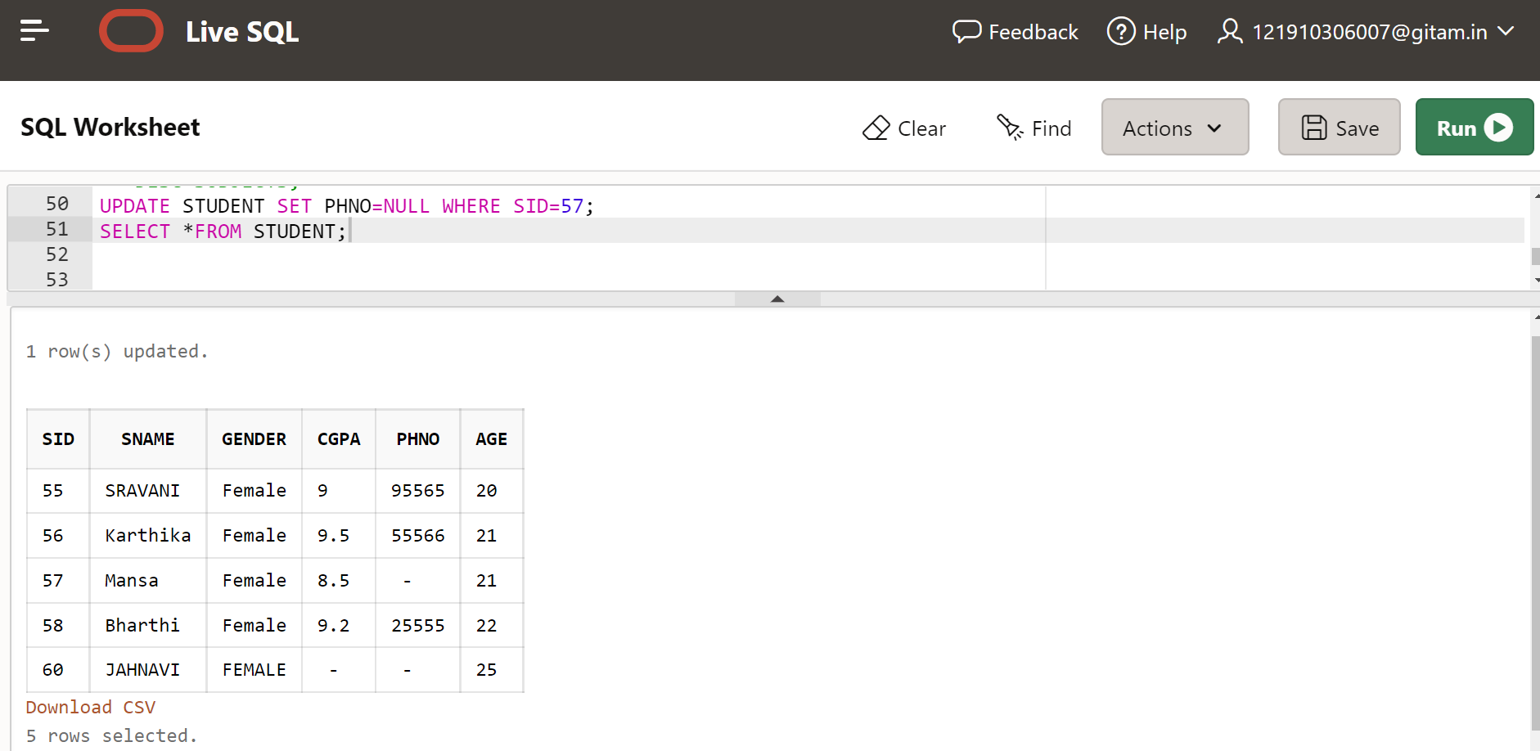

**14) Drop a column – Text Book from Course Relation.**

ALTER TABLE SUBJECTS DROP COLUMN TEXTBOOK;

SELECT* FROM SUBJECTS;

**Output:**

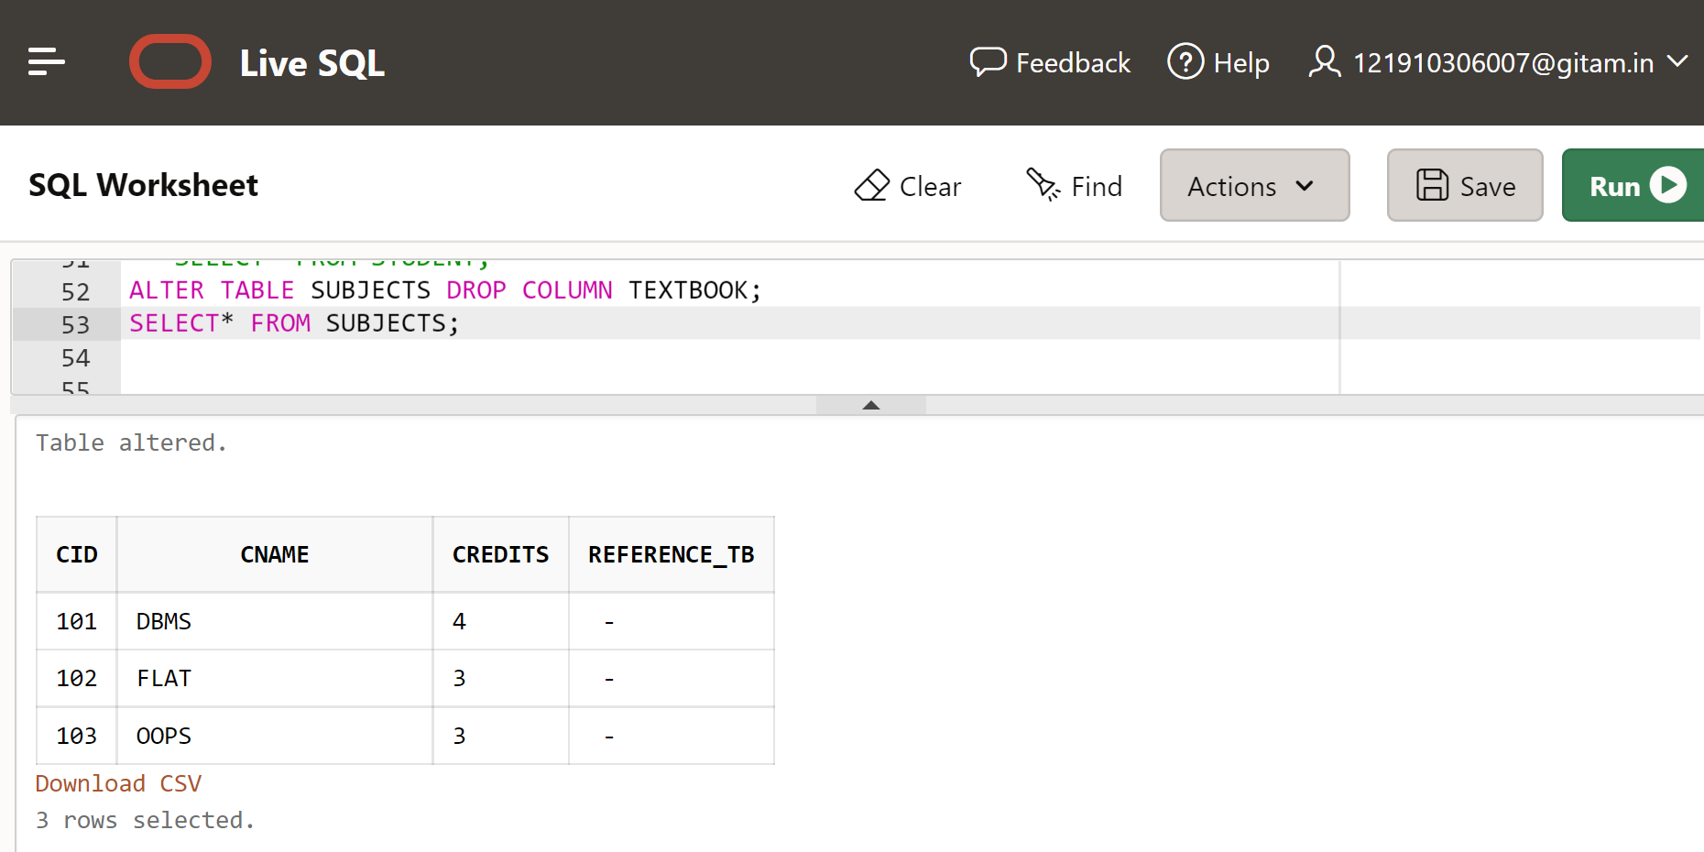

**15) Truncate the Student Relation and Display the Result**

TRUNCATE TABLE STUDENT;

SELECT* FROM STUDENT;

**Output:**

